# CST8215 – Database – Lab Section 323 – Assignment 1

## Team members:

Yanzhang Wu 041056465

Yongjing Ge 041057942

Boling Zhang 041058885

## Chosen scenario:

**Scenario 1**

## Entity:

Customer – this entity is used to keep track of the customers.

Order – this entity is used to keep track of order information.

Product – this entity tracks product inventory.

Part – this entity tracks parts that compose products.

## Business Rules:

A customer can place one or more orders.

Each customer must be on file before an order can be placed.

An order must have one and only one customer.

Each order contains at least one product.

Products may or may not be ordered by customers.

Products can be ordered by many different customers.

Products are made up of multiple parts.

The same part can be used in numerous products.

All parts are useful for products.

Product data is updated accordingly along with the part inventory data.

## Unknown:

How many phone numbers could a customer have?

How may mailing address could a customer have?

How may shipping address could a customer have?

How could a customer be qualified for a discount and how much is it?

What is the limit of a customer’s credit?

How many lines could be listed on an order?

## Assumption:

### Customer:

A customer must have at least one phone number.

A customer must have one and only one mailing address.

A customer may have zero or one or more than one shipping addresses. If a customer has no shipping address, then the mailing address is used instead.

Each shipping address will have a computer-generated number (shipping address ID).

If a customer spends above $1000.00 in a year period, then give a 3% discount on each item purchased by the customer.

A customer has one unique customer ID.

A customer must provide his/her full name.

A customer must have a credit limit. The credit limit cannot be negative, and the maximum value is 99999.99.

A customer may or may not have discount amount. If a customer has no discount, the discount is set as 0.0 in the database. The discount cannot be negative.

### Order:

Currently, the order can have up to 10-line items. However, in this database design, this limitation has been discarded.

Each order will have a computer-generated number (order ID).

Each order must record the purchase date.

Each order must record the purchased products and quantities for each kind of products.

Orders can be filled, partially filled, or cannot be filled depending on the product inventory quantity.

Orders that can be filled or partially filled are shipped immediately, and the product data is updated accordingly.

Orders, or partial orders that cannot be filled will be backordered.

Backordered quantity will not be shown in the table since it is a derived value.

### Product:

Products must have unique product code.

Products must have product description and inventory quantity.

It is possible that the quantity of the product is 0.

Products must have its standard price. Price cannot be negative.

As products are manufactured the product data is updated accordingly along with the part inventory data. The product inventory cannot be negative.

### Part:

Parts must have unique part number.

Parts must have their own description and quantity.

Products are made up of multiple parts. The same “part” can be used in numerous products.

Part inventory cannot be negative.

## Reflection

We have decided to keep our Table Customer in 2NF. The column that tracks zip-code will be kept in the table along with the columns that track address data. We understand that this violates the 3NF rule which requires transitive dependencies to be removed. However, we have decided to conduct denormalization for better performance.

(Please find conceptual and physical diagrams on next page)

## Screen shots of conceptual and physical diagrams

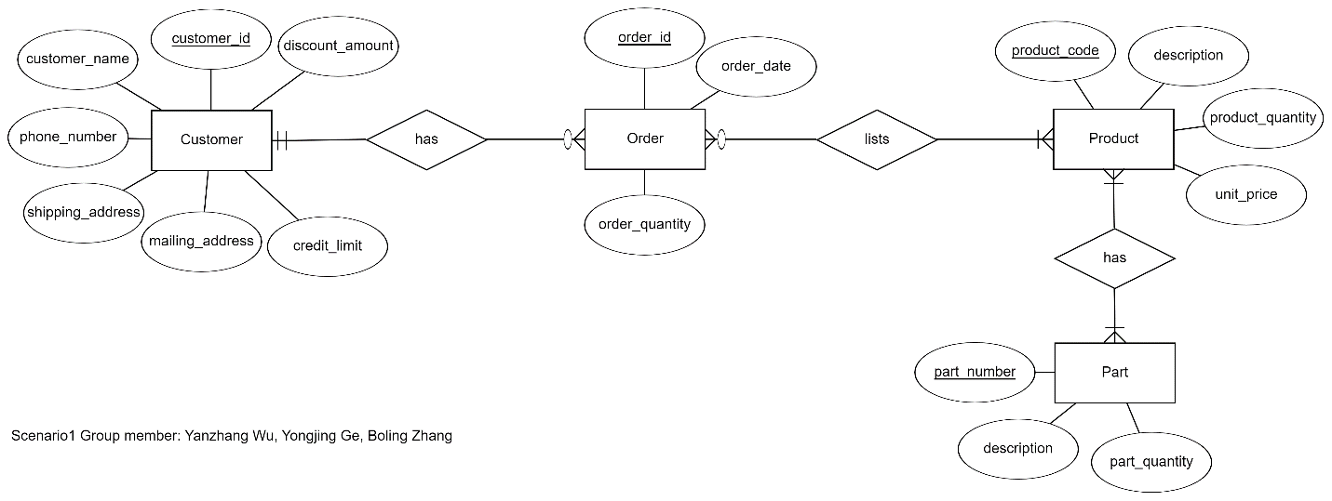

Figure . Screen shot of the conceptual diagram of Scenario 1

Figure . Screen shot of the physical diagram of Scenario 2

(Above diagrams are also submitted along with this document)